PRESS RELEASE

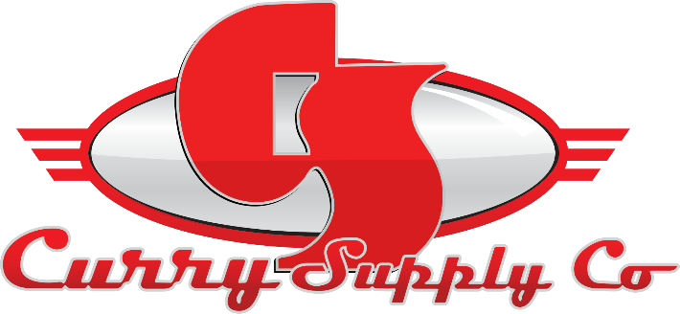
CONTACT INFORMATION:
Curry Supply Co.
Sara Herron
Marketing Coordinator
+1 814-505-5627
sherron@currysupply.com

RELEASE DATE:
October 26, 2022

CURRY SUPPLY CAT FLEET RECAP
The Curry Supply team had a wonderful time at the 2022 NACD Procurement & Fleet Group Conference, hosted in Indianapolis, IN, by MacAllister Cat.

INDIANAPOLIS, IN, October: The Curry Team had a wonderful time at the 2022 NACD Procurement & Fleet Group conference and were thankful and appreciative to have been invited to the event. Jeff Shaw, VP of Sales and Marketing, along with Marshall Hale and Tanner Denny, both Regional Sales Managers, attended the conference to represent the company.

Attendees mentioned how refreshing it was to get back to an in-person trade show and were pleased to see such a large turnout. The conference allowed our reps to meet with many familiar faces and make new connections throughout the week, both on the dealer and supplier sides. It allowed for meaningful interactions and face-to-face time with valuable contacts.

Marshall Hale stated, "Caterpillar events always impact me personally, and I get to further my relationships with existing clients and connect with customers from inside and outside my territory. I am constantly picking up valuable industry news, making new vendor contacts, and hearing about new products and companies open to new distribution partnerships. I enjoyed seeing all my dealer contacts out there and taking the time to talk with me about the possibility of getting an eye on some new products. I appreciate every CAT event Curry Supply is invited to attend, but the fleet show is always a staple throughout the year! I look forward to many new faces next year and have big plans for Curry to stand out as an exhibitor."

The main takeaway from the conference was the meaningful conversations with professionals in the industry to discuss the possibilities of:

- New potential quoting opportunities.
- Developing new demo opportunities.
- Meeting new contacts on both the dealer and supplier sides.

We take pride in finding optimal solutions and supporting our partners and clients in any way necessary for them to achieve both personal and professional growth. Events like the fleet conference allow for open conversation around industry news and standards enabling us to become our best.

Tanner Denny also mentioned, "It was inspiring to be a part of this year's conference again. It was great to see many familiar faces and get to meet a lot of new ones. Seeing MacAllister's fantastic facility and the Indianapolis 500 speedway was a great experience.”

Overall, there was a great turnout, and MacAllister did a great job setting up a valuable event for the vendors. The team appreciated the ability to meet with new and existing clients in person to share helpful industry news. The conference was a great experience, and we look forward to next year's event hosted by Wagner CAT in Denver, CO.

A family-owned company since 1932, Curry Supply has grown to be one of America's largest manufacturers of commercial service vehicles. With locations in Pennsylvania, Texas, and Arizona, the company is equipped to provide custom and work-ready trucks for the agriculture, construction, mining, oil and gas, rail, rental, and waste industries. To learn more, visit currysupply.com.

###

