PRESS RELEASE

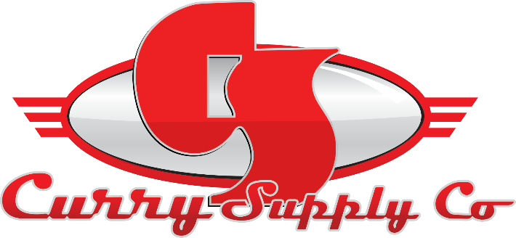
CONTACT INFORMATION:
Curry Supply Co.
Sara Herron
Marketing Coordinator
+1 814-505-5627
sherron@currysupply.com

RELEASE DATE:
09/06/2022

CURRY SUPPLY 2022 CAT DEALER UEM
Curry Supply is excited to be a sponsor at 2022 CAT UEM, Chattanooga, TN, September

Altoona, PA, August – Curry Supply is excited to announce our attendance at the CAT Dealer UEM 2022. We are looking forward to the opportunity to expand upon and forge new relationships with trusted dealers, distributors, and manufacturers.

Your Jobs. Our Trucks. Since 1932, our family-owned business has been helping customers get the job done, and Curry Supply has grown into one of America's largest manufacturers and dealers of commercial service vehicles.

Our vast line of service vehicles includes dust control-environmental, hauling and delivery, highway safety, mobile service, off-road applications, and more. Our dedicated team works directly with our customers to better understand their needs and deliver products that meet and exceed their expectations. Our customer-focused approach to manufacturing sets us apart and collaborating with our customers drives our product innovation above and beyond that of our competitors.

Sr. Director of Sales, Will Buddin, explained, "We are very excited to attend the 2022 CAT UEM conference. The CAT UEM is an organization we have been associated with for numerous years. It continues to allow us to connect, collaborate, and share best practices within the Caterpillar Used Equipment network. Each dealership is significant to our business model, and we are eager to be amongst them every year in this setting."

We want to thank Stowers Machinery for hosting the event and allowing us to meet with our valued partners and showcase our latest product offerings and innovations.

Stowers Machinery Corporation, a CAT dealer with deep roots and rich history, was founded in 1960 by three brothers and is celebrating their 60-year commitment to the East Tennessee construction industry.

If you will be in attendance, swing by our table and speak with our Regional Sales Manager, Steve Nelson, or our Off-Road Sales Manager, Tom Schnackenberg.

When asked about the event, Shnackenburg stated, "I am looking forward to another UEM in Chattanooga to visit with long-time acquaintances! Even though I talk to most of the UEMs throughout the year, it is always good to visit "one on one." Curry Supply and I value and appreciate the long-standing relationship with all the CAT dealers in this network."

At Curry Supply, we pride ourselves on embracing and engaging in a culture of continuous improvement. We start by focusing on understanding the application and providing our clients with engineered solutions that enable them to perform their jobs more effectively and efficiently.

###

