PRESS RELEASE

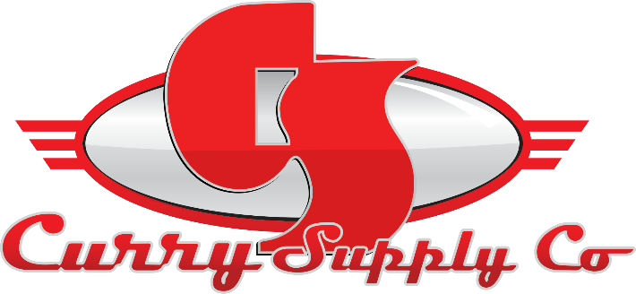
CONTACT INFORMATION:
Curry Supply Co.
Sara Herron
Marketing Coordinator
+1 814-505-5627
sherron@currysupply.com

RELEASE DATE:
September 20, 2022

CURRY SUPPLY SPONSORS NACDPFG 2022
Curry Supply is a proud sponsor of the 2022 CAT Fleet Conference, Indianapolis, IN

ALTOONA, PA, September –Curry Supply is excited to announce our attendance at NACD Procurement & Fleet Group. We look forward to sharing best practices, networking with fellow dealers and partners, leveraging relationships with vendors, and supporting the Group Procurement Organization.

Your Jobs. Our Trucks. Since 1932, our family-owned business has been helping customers get the job done while growing into one of America's largest manufacturers and dealers of commercial service vehicles. Our vast line of service vehicles includes dust control-environmental, hauling and delivery, highway safety, mobile service, off-road applications, and more.

We are looking forward to our time at NACDPFG. When asked about the event, Regional Sales Manager Tanner Denny stated, "The CAT fleet conference is an excellent opportunity to meet all the fleet managers in one location face to face. We get to discuss current obstacles and struggles in the market, allowing Curry Supply and myself to help with our special equipment, sales, and services. I look forward to seeing familiar faces again this year and making new relationships".

We are excited to fulfill Procurement & Fleet Group's mission of raising the level of procurement and fleet professionalism among members by advancing the strategic value of procurement and fleet to the dealers we represent. We want to thank MacAllister CAT for hosting the event and allowing us to meet with our valued partners and showcase our latest product offerings and innovations.

If you will be in attendance, swing by lot number 1 and speak with one of our Regional Sales Managers, Tanner Denny or Marshall Hale. Visit our display to learn more about our unique services.

At Curry Supply, we pride ourselves on embracing a continuous improvement culture. We start by focusing on understanding the application and providing our clients with engineered solutions so they can perform their jobs more effectively. Our dedicated team works directly with our customers to understand their needs and deliver products that meet or exceed their expectations. Our customer-focused approach to manufacturing sets us apart and collaborating with our customers drives our product innovation to go above and beyond.

A family-owned company since 1932, Curry Supply has grown to be one of America's largest manufacturers of commercial service vehicles. With locations in Pennsylvania, Texas, and Arizona, the company is equipped to provide custom and work-ready trucks for the agriculture, construction, mining, oil and gas, rail, rental, and waste industries. To learn more, visit currysupply.com.

###

