PRESS RELEASE

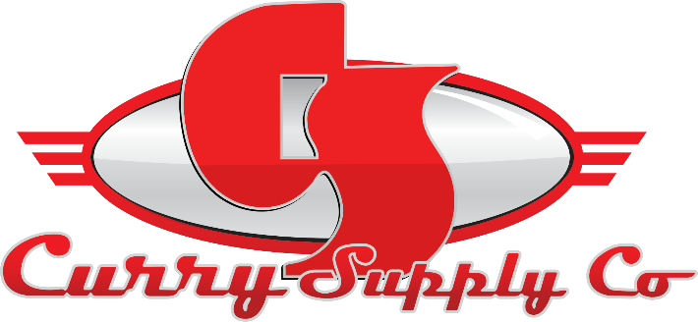
CONTACT INFORMATION:
Curry Supply Co.
Sara Herron
Marketing Coordinator
+1 814-505-5627
sherron@currysupply.com

RELEASE DATE:
09/01/2022

CURRY SUPPLY COMPANY HIRES SARA HERRON AS MARKETING COORDINATOR

ALTOONA, PA, August – Curry Supply has appointed Sara Herron as the company's marketing coordinator. In this role, Sara will assist the marketing director through the company's marketing efforts and strategies to promote our products and services. Specifically, she will help manage digital and traditional advertising, web properties, social channels, content creation, and build brand awareness while also focusing on events and community involvement.

Sara stated regarding the position with Curry Supply, "I am honored to accept the marketing coordinator position and eager to see where it takes me. I am excited to hit the ground running, and I do not doubt that big things are in store for myself and Curry as a whole".

Sara currently resides in Altoona, Pa. She recently graduated from Penn State Altoona with a Bachelor of Science in Business with a concentration in marketing and management and a minor in entrepreneurship. While at Penn State, she was actively involved and served as the President of the Sheetz Fellows Program. She is a Blair County Chamber's Young Professionals member and a current student in the Leadership Blair County Program. In her free time, she enjoys spending time with friends and family, traveling, volunteering, and working out.

ABOUT CURRY SUPPLY COMPANY:
A family-owned company since 1932, Curry Supply has grown to be one of America’s largest manufacturers of commercial service vehicles. With locations in Pennsylvania, Texas, and Arizona, the company is equipped to provide custom and work-ready trucks for the agriculture, construction, mining, oil and gas, rail, rental, and waste industries. To learn more, visit currysupply.com.

[Boilerplate] A family-owned company since 1932, Curry Supply has grown to be one of America’s largest manufacturers of commercial service vehicles. With locations in Pennsylvania, Texas, and Arizona, the company is equipped to provide custom and work-ready trucks for the agriculture, construction, mining, oil and gas, rail, rental, and waste industries. To learn more, visit currysupply.com.

###

